Final Project

Michael Woodmansee

# Overview

For my final project I will be creating a windows program the will upload an image and tell the user if and how it was modified.

# Goals

1. Creation of the program (base program, but no working detector)
2. The creation of an image modification detector
3. Creating 10 fake images and get 10 real images to run through the program
4. Learning to push visual studio projects to github.

# Specifications

* For this project I will be using visual studio 2019 , for building the windows program.
* For documentation i will be using Google docs and slides.
* All project file will be hosted on GitHub under a private repository.
* I will be following an agile programming method and will be testing the program with every iteration.

# Milestones

## Program Creation

The program creation is the goal of creating a base program that will run on windows pc’s.

## Image Creation

Image creation entails the creation of 10 fake images and 10 real images to use in the program. These images will be stored in the repository.

## Modification Detector Creation

This is the most important part of the project and program. This component will have to be able to detect image modification and tell the difference between a natural(real) image and a fake image.

Current Snapshot of the program in visual studio 2019

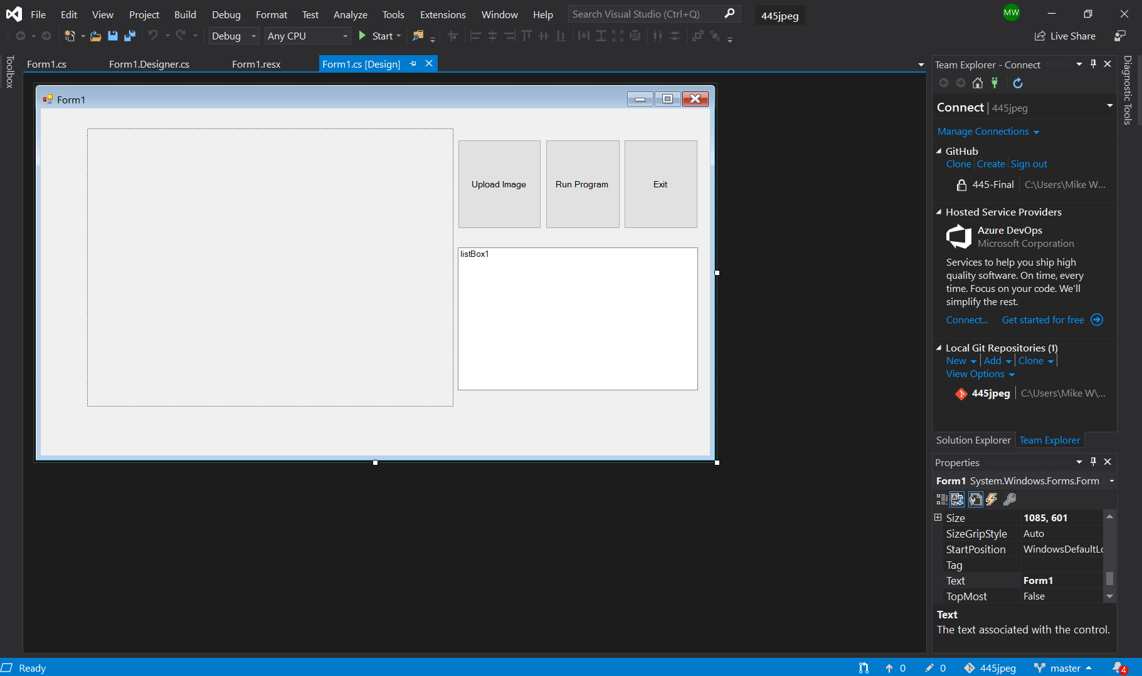

**Program Details**

* The upload image button will let the user select an image to test and display it in the picture box (left to the upload button).
* The run program button will run the image through the detector and display the results in the listbox (below the buttons).
* The Exit button just closes the program.